KEYBOAD DEVICE DRIVER


Submitted By:

Ehsan Javed
(2023-UOK-03608)
Obaid Bin Rasheed
( 2023-UOK-03682)
M. Haseeb Tariq
(2023-UOK-03689)

Session:2023-2027

DEPARTMENT OF COMPUTER SCIENCE
FACULTY OF COMPUTING AND ENGINEERING
UNIVERSITY OF KOTLI AZAD JAMMU AND KASHMIR

Project Name: KEYBOAD DEVICE DRIVER

Session:2023-2027

Submitted To: Mr. Mehtab Mushtaq signature:__________

Subject: OPERATING SYSTEM

Submitted By:
Ehsan Javed (08)
Obaid Bin Rasheed (82)
M. Haseeb Tariq (89)

Date of Submission: January 29, 2026

DEPARTMENT OF COMPUTER SCIENCE
FACULTY OF COMPUTING AND ENGINEERING
UNIVERSITY OF KOTLI AZAD JAMMU AND KASHMIR

TABLE OF CONTENTS
- INTRODUCTION .................................................................

- PROBLEM STATEMENT ...................................................

- OBJECTIVES .......................................................................

- SCOPE OF THE SYSTEM ..................................................

- FUNCTIONAL REQUIREMENTS ....................................

- NON-FUNCTIONAL REQUIREMENTS ..........................

- SYSTEM ARCHITECTURE OVERVIEW ........................

- LIMITATIONS .....................................................................

- CONCLUSION .....................................................................

1.INTRODUCTION
A keyboard device driver is a low-level system software component responsible for enabling communication between keyboard hardware and the operating system. It translates raw hardware signals generated by key presses into standardized input events that can be processed by the operating system and application software.
The keyboard device driver plays a critical role in user interaction, as it ensures accurate, timely, and reliable input handling. Without an effective keyboard driver, the operating system would be unable to interpret user keystrokes correctly, resulting in reduced system usability.

2.PROBLEM STATEMENT
Modern operating systems must support a wide variety of keyboard hardware, layouts, and input methods. Differences in hardware protocols, scan codes, and special function keys create challenges in maintaining consistent input behavior.
The absence of a well-designed keyboard device driver can lead to incorrect key mapping, delayed input response, compatibility issues, and system instability. Therefore, a reliable and efficient keyboard device driver is essential to ensure accurate input processing across different computing environments.

3.OBJECTIVES
The primary objectives of this synopsis are:
- To study the role and importance of a keyboard device driver in an operating system.
- To identify the functional requirements necessary for accurate keystroke handling.
- To define non-functional requirements that ensure performance and reliability.
- To describe the scope and limitations of the keyboard device driver.
- To present a high-level architectural overview of the driver.

4.SCOPE OF THE SYSTEM
The scope of the keyboard device driver includes detecting key press and key release events, interpreting scan codes, and transmitting key events to the operating system in real time. The driver supports standard keyboards and commonly used layouts.
The system focuses on software-level interaction between the keyboard and the operating system and does not include hardware manufacturing or electrical signal design. The scope is limited to general-purpose computing systems.

5.FUNCTIONAL REQUIREMENTS
The keyboard device driver must fulfill the following functional requirements:
- Detect all key press and release events accurately.
- Translate hardware scan codes into operating system key codes.
- Support modifier keys such as Shift, Control, and Alt.
- Handle special function keys and extended keys correctly.
These requirements ensure correct and efficient communication between keyboard hardware and the operating system.

6.NON-FUNCTIONAL REQUIREMENTS
The keyboard device driver must satisfy the following non-functional requirements:
- Performance: The driver should process keystrokes with minimal latency.
- Reliability: The driver must operate continuously without failure.
- Compatibility: It should support different keyboard models and layouts.
- Security: The driver must prevent unauthorized access to keystroke data.
Non-functional requirements are critical to system stability and user experience.

7.SYSTEM ARCHITECTURE OVERVIEW
The keyboard device driver architecture consists of interrupt handling mechanisms, scan code processing modules, and communication interfaces with the operating system kernel. When a key event occurs, the keyboard generates an interrupt that is handled by the driver.
The driver processes the input, converts it into a standardized format, and forwards it to the operating system’s input management system. This layered architecture improves modularity and maintainability.
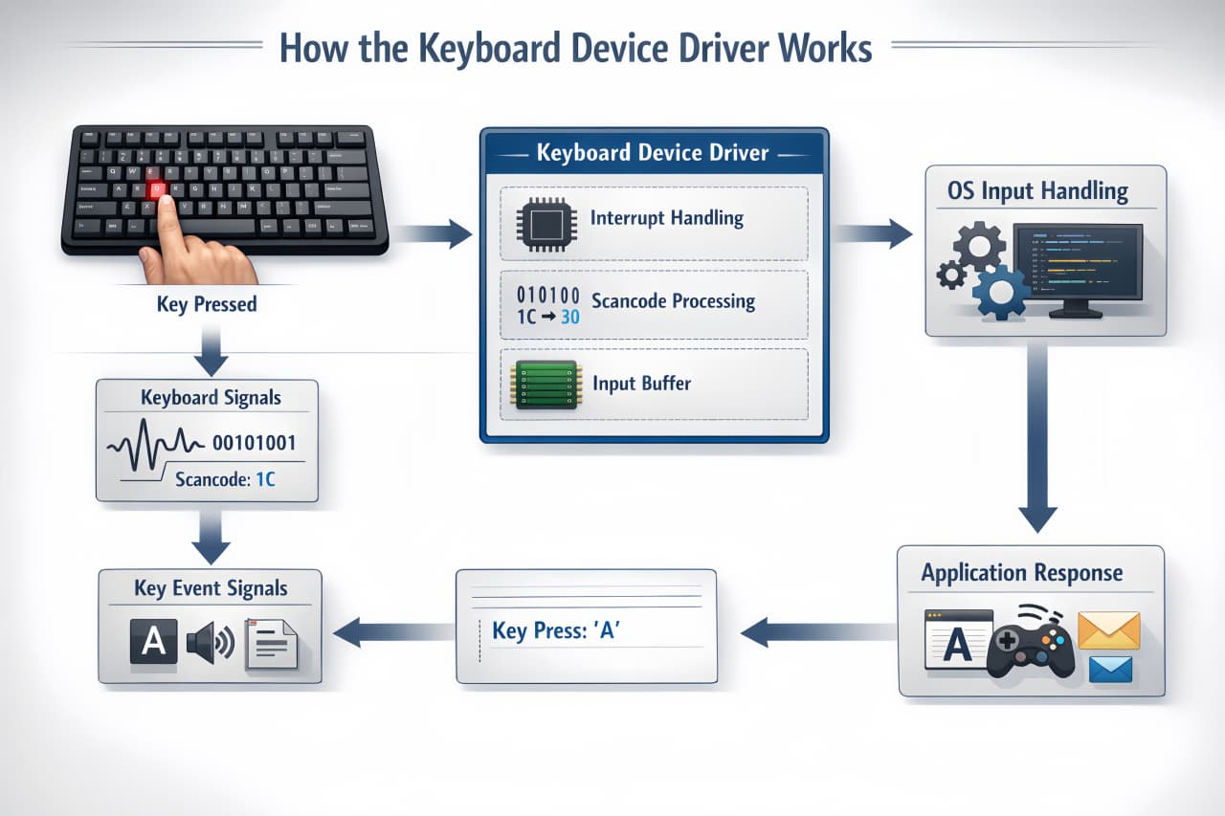

8.LIMITATIONS
The keyboard device driver may face limitations related to hardware compatibility and support for advanced or proprietary keyboard features. Older systems may not fully support newer keyboard functionalities.
Additionally, performance may be affected under heavy system load or when running on outdated hardware platforms.

9.CONCLUSION
The keyboard device driver is a fundamental component of an operating system that enables effective human-computer interaction. A well-designed driver ensures accurate input processing, system stability, and improved user experience.
This synopsis provides a structured and professional overview of the keyboard device driver, following standard synopsis manual guidelines suitable for academic and technical documentation.

10.Reference:
Page key (youtube channel) https://youtu.be/YtnNX074jMU?si=YL1ARu1HkOuIhcwG
Chat gpt (for problem solving)
Gemini(for images and ideas)
Stack overview(google) https://share.google/fs0aMbtFXEpSidIpy

